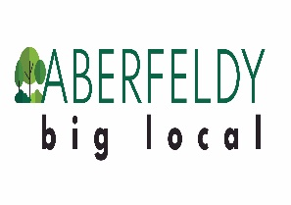
Application deadline: 9 am, 20 February 2023
Please return to: hello@aberfeldybiglocal.com

Aberfeldy Big Local
hello@aberfeldybiglocal.com
07442251109
Community Chest Guidance
Introduction and Eligibility
Aberfeldy Big Local is offering Community Chest grants of up to £1,000.
Based on our priorities, we expect a project grant to contribute toward one or more of these areas:
- Make Aberfeldy a better place to live
- Contribute toward capacity building, e.g., grow new ideas, build community relationships/networks, develop knowledge or skills, etc.
- Address inequality
To be eligible, an individual must be a resident or work/volunteer in Aberfeldy. Organisations are similarly eligible if their organisation is registered in Aberfeldy or they already work/serve Aberfeldy residents.
For organisations/groups, you must be small-to-medium sized, which is defined as having less than 250 employees or with a turnover of less than £45,000 and a balance sheet totalling less than £39,000.
Projects must benefit Aberfeldy residents. This likely means your project is delivered for, with, and/or by residents.
You don’t need previous experience running this project, but you need to be able to demonstrate that the community have shown it is needed.
This might also be the first time you have led a project. Whatever your experience, the Aberfeldy Big Local team are here to help you. We can explain the application process, talk through your proposal, support you with financial procedures, and help with reporting.
We will be offering rounds of grants every 6 months. Therefore, your project must be delivered within a period of 16 weeks.

For constituted community groups, companies, charities, freelancers or similar:
These structures will be required to have:
- Public liability insurance
- Health and safety policy

Those aiming to work with vulnerable adults or children will also need:
- Safeguarding policy
- Relevant DBS checks for staff and volunteers

Organisations working with staff will also need:
- Employers liability insurance

If you are a start-up and require support with this, please contact our team. We want you to apply.

For volunteers or voluntary groups:
You will be provided with the necessary support to ensure the above requirements are met where relevant.

Community Chest Process
Applicants will be required to submit an application form. This is due by: 9am, 20 February 2023
The team will hold a session in which we can give you feedback on your proposal and help you complete your application. This will be held on: 7 February 2023 from 1-3 and 4-6 pm. If you can’t make these sessions but would like support, please contact our team.
Successful applicants will then be provided an acceptance letter with terms and conditions, which they will need to sign. They will also need to provide bank details and insurance at this stage, and the grant will be provided in two instalments: at the beginning and middle.
Prior to implementation/delivery, we will also need to see that you’ve undertaken a risk assessment. Again, if you require support with this, please contact our team. We don’t want you to be deterred from applying.
Community Chest recipients will also be required to collect data, feedback, and photos from participants and audiences where possible and keep proof of expenditure. You will be required to bring this information to a middle and end meeting or call with ABL staff, during which we will work together to evaluate your project.

Project Planning
Asking yourself these questions will help:
- How is your project delivered with, for, and/or by residents?

- Does your project address our priorities, i.e, improve Aberfeldy, address inequality, and/or build capacity?

- Has the community demonstrated that the project is needed? (Maybe you’ve consulted with the community or tested this idea before.)

- How will you make sure the community engages with your project?

- How will you collect data, photos, and feedback from project partners and participants?

Community Chest Case Study

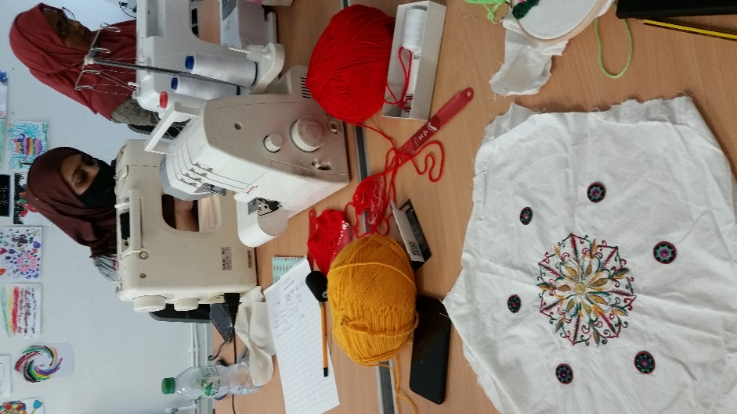
A local tailor successfully applied to run workshops in the Big Local space, using a Community Chest grant to pay for equipment and tutor costs. The workshops initially included a variety of activities, like daytime craft and crochet, but it became clear that the highest demand was for evening sewing workshops for women. Each week, women came together to learn new sewing skills, meet new people, and support each other with mental health and empowerment. The project lead also developed new skills managing and promoting workshops.
Following this project’s successful delivery, the project lead secured additional funding to deliver an additional 16 weeks of sewing workshops. One participant explained that she looked forward to the weekly sessions because it helped her destress from struggles at home; another explained how learning to sew their family’s garments helps them financially; other participants have since grown their own project ideas as a result of the relationships and support these women have grown together through the project.

