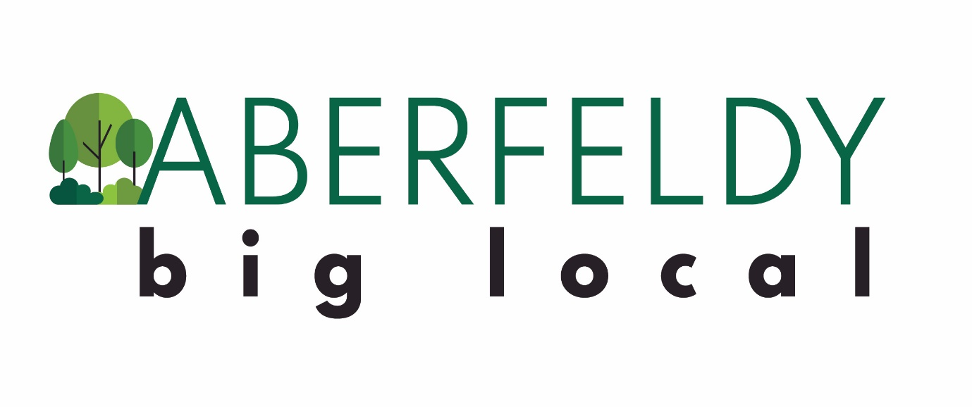
Local Plan 2020-22

About Aberfeldy Big Local
Aberfeldy Big Local (ABL) has been inexistence since 2013. Part of the national Big Local programme, ABL is a group of residents working to invest £1million of Lottery money into the estate up until 2026. Big Local has gifted £1 million each to 150 areas across England. The aims of the Big Local programme are that:
- Communities will be better able to identify local needs and take action in response to them
- People will have increased skills and confidence, so that they continue to identify and respond to needs in the future
- The community will make a difference to the needs it prioritises
- People will feel that their area is an even better place to live
In Aberfeldy, we are investing this money to make the area a better place to live and allow all residents to benefit from the changes taking place in the community.
How Do We Operate?
We operate through a partnership of residents that meets once a month to make decisions on how to use the Big Local funding to benefit the whole community. All our members live in Aberfeldy. We work with Quaker Social Action, a charity based in Bethnal Green, to put our plans into practice. They hold the money on behalf of the partnership and support our work in the community. We employ staff to help us achieve our goals, including our ABL manager and staff at Tommy’s Tea Room.

Introduction to Our Plan
What Changes are on the Horizon for Aberfeldy?
Aberfeldy is going through a massive process of regeneration. There are several schemes underway or planned for Aberfeldy, including Aberfeldy Village and the Leven Road Gas Works, which pose a variety of opportunities & challenges for our community. The planned schemes will transform the area by increasing the local population by around 15,000; creating local jobs and business opportunities; bring increased traffic, air and noise pollution; build more homes; and transform the culture and look of the area. The effects will be huge.
How can we respond to the challenges and take advantage of the opportunities presented by regeneration?
Community is Easy to Destroy, but Difficult to Build Up- Our Vision for Aberfeldy
We want to live in an area where there is a strong community spirit, with plenty of places to meet and have fun with our neighbours on a regular basis. We want to mix with different people and bond over shared interests. We want everyone to be proud to call Aberfeldy home and feel stable and secure living here. The community should have its voice heard on an equal footing with property developers, landlords and the council as they develop the area. We want to be partners in regenerating the area.
People, Places and Power
Only a strong and connected community can take advantage of the growing opportunities in Aberfeldy. To build a strong and confident community we will invest in our PEOPLE to become active in local life, taking the lead on activities and events that bring people together and build community spirit. We will invest in our young people to have a brighter future. A community needs vibrant, authentic and welcoming PLACES for people to meet and mix. We will create places where we mix with our neighbours, build new relationships and develop a sense of pride in the area. We will also build the POWER of Aberfeldy residents to influence the changes taking place in the area and take advantage of the opportunities they bring. We’ll do this by connecting with local residents & organisations to develop the community’s voice to be heard on an equal footing with developers, the local council and other agencies.

Reflections on Our Last Plan (2017-20)
Community Chest | What Went Well
We provided grants of up to £500 to 28 different local groups and activities. These included: fitness classes, yoga, coach trips, healthy eating workshops, ballroom dancing, community choir, knitting, boxing, glass-blowing, afternoon tea, photography exhibition, karaoke, cricket, football, film nights and a stay and play group. | The community chest allowed local people to try new things, meet new people, and have shared experiences with their neighbours. Some local people took the lead in organising activities and events, some of which have kept going after the initial grant, building their skills and confidence to do so in the future.
 | Room For Improvement
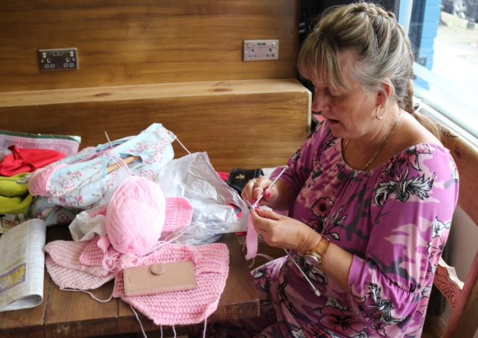 | We want to encourage more Aberfeldy residents to take the lead in organising activities and groups to build the skills of local people. The cost of hiring space for activities in Aberfeldy can be prohibitive for people. We want to address this in our new plan by looking at how to make more accessible community spaces.

Aberfeldy Football Club | What Went Well
We sponsored Aberfeldy FC for 3 years. We wanted to support the club to expand their good work with young people in Aberfeldy. The funding allowed them to develop an under-14s and under-16s youth team, as well pay for new kit, training equipment, training venue hire and league entry fees. They also set up Aberfeldy FC Women too. | Sponsorship allowed the team to stabilise and grow. In supporting this local institution, the partnership are putting faith in its residents to build positive opportunities for young boys and girls as an alternative to falling into gangs and drug dealing, which remain a draw on young people who go down the wrong paths in life.
Room For Improvement
Aberfeldy FC explore options for incorporating to allow them to diversify their income sources in future, however, they decided not to do this due to the obligations involved. The club will need to secure alternative sponsorship in future. | 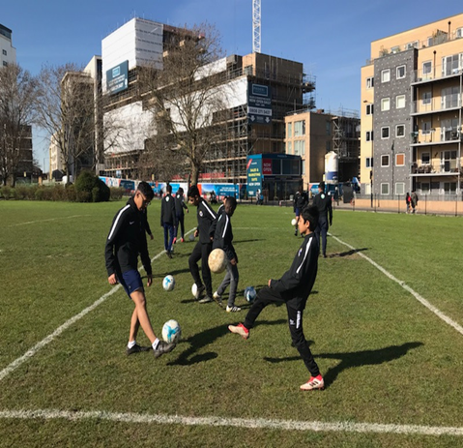

Tommy Flowers Pub
We established the Tommy Flowers pub in a dis-used florist shop on Aberfeldy Street. We brought an external operator in to run the pub, which is open Thurs-Sun and holds regular events such as karaoke, ‘talkaoke’ and glass-blowing. | 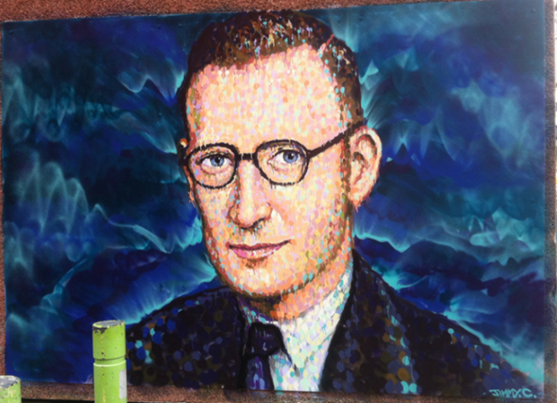
What Went Well | Room For Improvement
The pub fills the gap left by the demolition of the old Aberfeldy Tavern. The pub operator is trying to build a bridge between older and newer residents through a mixed programme of events. The pub has become one of the main centres of the local community. | More can be done to attract local people into the pub on a regular basis, including extending the opening hours & putting on different events that appeal to local people. Financially, the pub is struggling- better financial management and a concerted effort to increase custom can improve this. Putting the pub in a financially stable position will help it be able to have greater reach in the community.

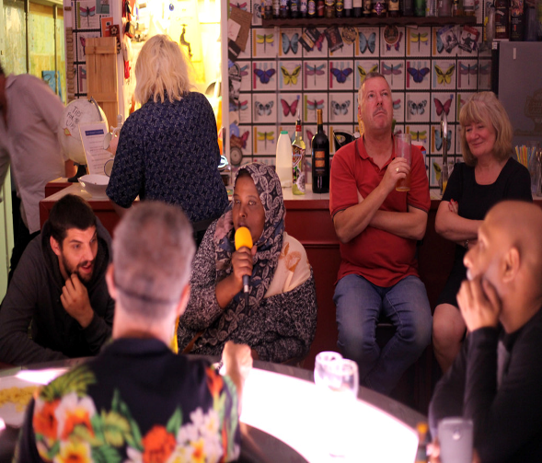 | Tommy’s Tea Room
 | We run a tearoom in the Tommy Flowers pub Mon-Weds 9am-2pm. Staffed by 2 local residents, the tearoom provides a social space for local residents to meet during the week and a base from which to promote the activities of Aberfeldy Big Local. People can come and have tea, coffee, cake and rolls, all provided on a donation basis.
Room For Improvement | What Went Well
Footfall on Aberfeldy Street is low, so visitor numbers are not very high. Its location in the pub can put off Muslim neighbours coming in. The space is small and it’s layout/decoration etc. is not under our control, which makes it harder to promote everything ABL has to offer. We pay a relatively high price to rent the space for the tea room. Going forwards we will be re-evaluating the tea room as a social space and means of promoting ABL and creating a plan for its continuation or evolution in Aberfeldy. | The tea room provides a place for people to come during the week, who would not go elsewhere and there is no obligation on people to buy anything to be in the space. The tea room has been helpful in acting as a base to talk to people about ABL.

Discretionary Projects | What Went Well
Through our discretionary projects fund we have been able to respond to opportunities and issues as they have arisen over the past few years. In total, we have supported 5 different projects through this that meet local needs & interests:  - Two summer schemes for children in the school summer break, run by Aberfeldy FC  - Tiny Tots parent and toddler group held at St Nicholas’ Church  - A weekly youth club on Friday evenings at the church hall, run by Aberfeldy FC  - A photography project called ‘Aberfeldy Portraits’ at the Tommy Flowers pub,  - Opening a new boxing club on Aberfeldy Street | The summer schemes and youth club have been a great success, providing a local offer for young people to do something constructive with their time. Located in Aberfeldy, these activities fill the gap left by the withdrawal of council-funded youth services on the estate. They are also completely resident-led, building the experience of our residents to do things for themselves.  Tiny Tots fills another gap in Aberfeldy, providing a valuable opportunity for young families to socialise.  The funding awarded to the boxing club will contribute towards opening a boxing gym on Aberfeldy Street where local people can train with professional coaches. The gym will have a big focus on young people, providing opportunities for them to develop their fitness, discipline and competitiveness and build supportive relationships.
 | Room For Improvement
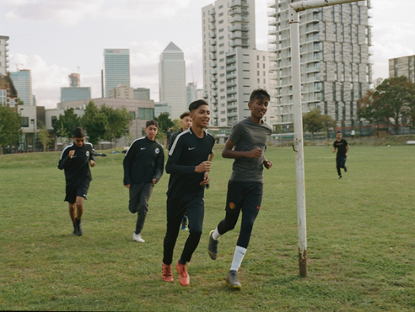 | Going forwards, we will look to secure funding for some of this activity as we feel it is important for the Aberfeldy community. We will invest our funding in a more targeted and strategic way in our new plan, as local opportunities have become clearer.

Summer Fun Day | What Went Well
An annual summer fun day for all residents to get together, have fun and find out more about ABL.  Room For Improvement  We want to get more local residents involved in planning and putting on the event. We also want to do more events in the community throughout the year, with local people volunteering their time to put them on. | The event attracts 300-400 people each year, and has been a success each time. Feedback from residents is that they’d like to see more events like this throughout the year. The event also gives us a chance to talk to residents about their priorities for the area.
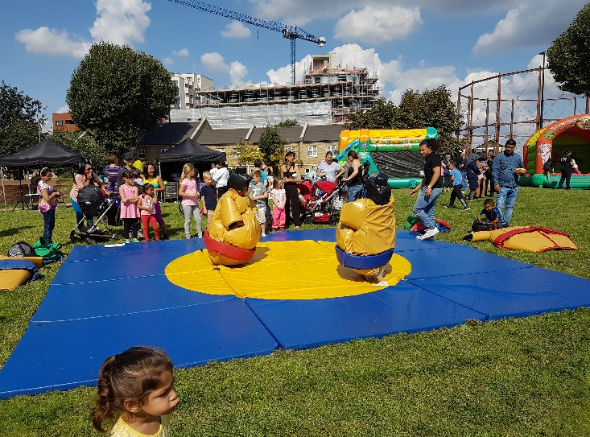

Creating This Plan
Whilst creating this plan we spoke to Aberfeldy residents about their ideas and priorities for change in the area. We spoke to people at our annual fun days, local events, online and informally. This is what people said.
Fun Day 2018- What Do Young People Want in Aberfeldy?

Fun Day 2019- What Needs to Change in Aberfeldy?
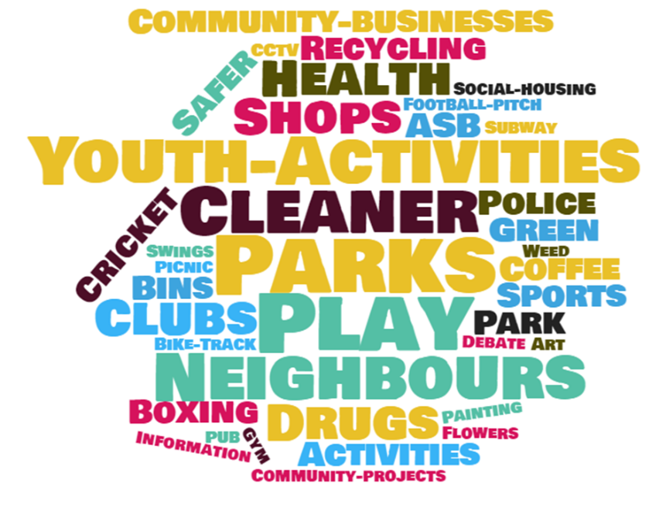

Online Survey- August 2018

2017-2020 Review
In 2017-20 we supported a number of initiatives and projects in Aberfeldy. Here is what we did.
Community Chest
We provided grants of up to £500 to 28 different local groups and activities. These included: fitness classes, yoga, coach trips, healthy eating workshops, ballroom dancing, a community choir, knitting, bingo, boxing, glass-blowing, an afternoon tea, photography exhibitions, karaoke, cricket, football, film nights and a stay and play group.
What Went Well
The community chest allowed people to try new things, meet new people, and have shared experiences with their neighbours. People in our community took the lead in organising activities and events, some of which have kept going after the £500 was spent, providing more opportunities for the community to get together. Some local residents have used Community Chest funding to develop ideas for their own business, such as personal training.
Room for Improvement
We want to encourage more Aberfeldy residents to take the lead in organising activities and groups. The cost of hiring space for activities in Aberfeldy can be expensive, which stops people putting activities on. We want to address this by looking at how to make community facilities more accessible.
Q&A with Victor
Victor is a local resident who applied for a Community Chest grant from ABL to run fitness classes in the community. He has since developed his own Personal Training business, called Fit For What.
What do you do & why do you do it?
I am Personal Trainer who has lived in Aberfeldy all my life. I have been a trainer for over 8 years. We started running classes for the local community with a grant from the Community Chest. We have previously ran fitness transformation programme. We now currently run a fitness class for the local men of the community.
What did you use the Community Chest grant for?
We were able to pay trainers to run the sessions and pay to rent the church hall. This helped get my personal training business up and running by allowing me to give the sessions a try.
What challenges do you face as a new business? Did the grant help you overcome any of these? If so, how?
As a new business the challenges we face are usually start-up cost for projects to keep going. We were able to use the grant to fund some of our start-up cost which helped with reducing the stress of finances on the business.
What plans do you have to continue your activities?
We plant to run few more classes. We also so plan to take our expertise online and have people of the local community have subsidized rates on our online programme.
Aberfeldy FC Sponsorship
We sponsored Aberfeldy FC for 3 years. We wanted to support the club to expand their good work with young people in Aberfeldy. The funding allowed them to develop an under-14s and under-16s youth team, as well pay for new kit, training equipment, training venue hire and league entry fees. They also set up Aberfeldy FC Women too.
Numbers:
72 players in total
30 in the Senior Team
24 in Under 14s
18 in Women’s Team
What Went Well
Sponsorship allowed the team to stabilise and grow. In supporting our local club, the partnership are putting faith in local people to build positive opportunities for young boys and girls as an alternative to falling into trouble or going down the wrong paths in life.
Moving Forwards
Aberfeldy FC are exploring alternative ways to fund the club as ABL’s sponsorship comes to an end.
Youth Club
Aberfeldy FC also run a youth club on the estate. It runs twice a week on Mondays (TIME) and Thursdays (TIME) at St Nicholas’ Church hall on Aberfeldy Street. The club is free to attend and aimed at XX-XX year olds. Activities on offer include pool, sports, cooking, PS4 and trips out to trampoline parks, museums etc. Just turn up on the day to join.
Tommy Flowers Pub & Tea Room
We established the Tommy Flowers pub in a dis-used florist shop on Aberfeldy Street. The pub is open Thurs-Sun and holds regular events such as karaoke, a quiz, a Sunday afternoon cinema, ‘talkaoke’ and glass-blowing. On Monday-Thursdays in the daytime, we run Tommy’s Tea Room in the pub, offering homemade cakes, tea and coffee for sale on a donation basis, to provide somewhere for people to meet their neighbours and have a chat during the week.
What Went Well
Although it’s a fifth of the size, the pub goes some way to filling the gap left by the demolition of the old Aberfeldy Tavern. It has provided a place for people who’ve known each other for years to reconnect. The pub is welcoming to everyone and has become a place for Aberfeldy residents, new and old, to meet each other and make friends. Also, we’ve discovered some seriously good singers through the karaoke nights….and some seriously bad ones too!
The tea room is a welcoming space where you don’t have to buy anything to come into. It’s a relaxed environment where people can catch up and keep up to date with local goings on.
Moving Forwards
We will continue to support the pub and tea room, giving the space a facelift to make it more appealing to local people and organising more regular events to bring people together.
Tiny Tots
Aberfeldy is home to a large amount of young families. The area is cut off from the rest of Tower Hamlets and Canning Town, being bordered on all 3 sides by the A12, A13 and the River Lea. It is difficult for parents with young children to get out of Aberfeldy to access other local parent and toddler groups because of the time and cost involved in leaving the estate. This puts young parents & carers at risk of becoming isolated at such an important time in theirs and their child’s life.
ABL have supported Tiny Tots at St Nicholas’ church hall on Aberfeldy Street.
How Many Parents/Children Attend?
Tiny Tots gets an average of 18 parents per week. It is open to all to attend, for children ages 0-5 (pre-school). Mums, Dads, childminders, carers- everyone’s welcome. The group is very friendly and open to new people.
How Many Sessions Per Week and Where?
The session runs weekly in term time 10am-12pm at St Nicholas’ Church Hall on Aberfeldy Street.
Why does the church run Tiny Tots?
The Parish of Poplar runs the session as part of its mission to serve the local community. The group is non-religious, and is for anyone to attend.
What does Tiny Tots offer to local people?
Tiny Tots offers people a place to go and meet other parents and carers, socialise, make friends and find out whats going on in the area. It gives children the chance to play and socialise with other kids. Children have lots of things do to, including creative activities such as painting and playing with toys they might not have at home, like the ball-pit, play-house and tricycles.
How can people get involved?
If you want to attend the session with your children, then just turn up on the day and join in. It is free to attend.
Laura is keen for people to help her run the sessions as volunteers.
What Parents & Carers Have to Say
“It’s somewhere outside of the house to go to, as being indoors all day is boring!”
“A great way for my child to develop their social skills by playing with other children.”
“It’s great to get some chill time and to meet other parents to find out what’s going on.”
“The session is local to Aberfeldy, which means it is easy to get to whilst managing other things and we don’t have to pay for public transport. It’s a 5 minute walk from my flat, which is a Godsend!”
Aberfeldy Boxing Club
We have supported a local resident, Kirk, to open Aberfeldy Boxing Club in a disused shop unit at 29 Aberfeldy Street. The club will be open throughout the week and weekends to provide space for boxing training. A regular timetable of classes will be created for local people to get involved in the sport, including targeted sessions for kids, women and older people. The club will provide opportunities for people to get fit, learn discipline and be part of a community.
Q&A with Kirk
Why are you starting Aberfeldy Boxing Club?
The main reason for starting the club is to give kids an alternative to joining gangs. Boxing is a disciplined sport and it will hopefully give young people a constructive way to spend their time in the local area. If we can prevent even one kid from joining a gang, then we’ve done a good job.
What will the club offer the community?
The club is open to everyone. We will be running regular sessions for all parts of the community, including women-only and men-only sessions. The club is affiliated with England Boxing, so we offer the opportunity to be trained by qualified boxing coaches. We also offer boxing for fitness- if you don’t want to fight but want to get fit, boxing is a great sport for burning calories and building strength. The club is for the community, so come and see if you want to join.
What are your long term ambitions for the club?
We want to get local people and kids representing Aberfeldy in fights around the country. We want people to be able to discover their talent in the sport and take it as far as they can. We only have our current premises for a few years, until the building is demolished. Our aim is to move the club into a permanent home, in bigger facilities as Aberfeldy gets redeveloped.
How can people get involved?
The club is open for anyone to join. To join the club, you have to become a member. For adults, a year’s membership cost £25, and £3 per session. For under 16s membership is £10, and £1 per session. The club will open throughout the week in the afternoons and evenings. We have coaches providing one-to-one training during the daytimes, which can be arranged privately. If anyone is interested in volunteering to help run the club then please come and talk to us. We can offer you the chance to become trained as an England recognised coach or you can help us with other sides of the club such as admin, fundraising etc.

Creating This Plan
Whilst creating this plan we spoke to Aberfeldy residents about their ideas and priorities for change in the area. We spoke to people at our annual fun days, local events, online and informally. This is what people said.
Fun Day 2018- What Do Young People Want in Aberfeldy? Fun Day 2019- What Needs to Change in Aberfeldy?

Online Survey- August 2018

People
To build a strong and confident community we will invest in our PEOPLE to become active in local life, taking the lead on activities and events that bring people together and build community spirit. We will invest in our young people to have a brighter future.
What’s in the plan?
Community Chest
We will continue to run our Community Chest, offering up to £500 to people with ideas for activities, groups or events to benefit the community. We will run three rounds of funding each year in Spring, Summer and Winter.
Children & Young People
We want more activities for children and young people to do in Aberfeldy. The area has a lack of youth services and opportunities, and some young people risk falling into gangs and violence. We will support the development of better opportunities for young people in Aberfeldy. We will also support ideas for regular activities and groups for young people to give them options for getting involved. We also want to make sure that Aberfeldy gets its fair share of funding and attention from Tower Hamlets Council’s youth service.
Community Events
We’ll be organising and sponsoring more events in Aberfeldy to bring the community together and let old and new residents mix with each other, such as the summer fun day, fireworks night, Christmas events etc. We want more people to help us plan and organise these events.
Get Involved!
You can apply for Community Chest funding when it’s available. Look out for newsletters and on our website and Facebook page for information on the next round of money.
If you have ideas for activities for children and young people, and/or you’d like to volunteer to run activities, then get in touch with us.
If you want to help us work with the Council to get a better youth service in Aberfeldy, then think about joining the ABL committee.
If you want to help organise local events or have an idea for an event you’d like to see happen, let us know. We want more people to help out putting events on!

Places
A community needs vibrant, authentic and welcoming PLACES for people to meet and mix. We will conserve and develop the places where we mix with our neighbours, build new relationships and develop a sense of belonging to Aberfeldy.
What’s in the plan?
Community Spaces Fund
We will support the creation of new community spaces in Aberfeldy by offering kick-starter funding for business ideas that create new or improved places for local people to mix. There are opportunities to access units for these on Aberfeldy Street and at Poplar Works. We can support good ideas that will improve life in Aberfeldy.
Future Community Spaces
We will work with property developers and the council to plan and design vibrant, affordable and authentic community spaces as part of the regeneration of Aberfeldy. These will include cafes, shops, supermarkets, pubs, sports facilities, community halls etc.
Improving the Parks
We will be working with Tower Hamlets Council and local property developers to invest money to improve Millennium Green and the MUGA on Leven Road. These green spaces are not fit for purpose and can be improved so that more people feel safer using them, and the facilities are up to scratch.
Get Involved!
If you have a solid business idea that will provide a new place for people to meet, then you can apply for funding from the Community Spaces Fund. Check our website and Facebook for information on this.
If you want to be part of the conversation about future community spaces, amenities or the parks, get in touch with us or think about joining the ABL committee. We’re looking for people to help create ideas to improve things and get more people involved in creating future plans.

POWER
We will build the POWER of Aberfeldy residents to influence the changes taking place in the area and make sure that the future benefits everybody. We’ll do this by connecting with local residents & organisations to develop the community’s voice to be heard on an equal footing with developers, the local council and other agencies. We’ll support residents to take advantage of opportunities in the local area.
What’s in the plan?
Community Voice
The current plans for Aberfeldy reflect the most significant change to the estate since after World War Two. It’s a once in a generation opportunity to create a vibrant, welcoming and cohesive community. This can be an exciting time for the community.
To help do this, Aberfeldy Big Local commits to:
- Building an independent residents’ organisation to represent the community’s voice and interests
- Working productively in partnership with all stakeholders to make potential benefits a reality
- Supporting residents to take advantage of emerging economic, social and cultural opportunities

Membership Organisation
We will build the membership of Aberfeldy Big Local to give local residents greater control over the Big Local funding and a means to connect with others. This will help democratise decisions over our funding to ensure it has the maximum possible benefit for the whole Aberfeldy community.

